**Kinetic pathway of the ferroelectric phase formation in doped HfO2 films** [Lun Xu](http://aip.scitation.org/author/Xu%2C+Lun), [Tomonori Nishimura](http://aip.scitation.org/author/Nishimura%2C+Tomonori), [Shigehisa Shibayama](http://aip.scitation.org/author/Shibayama%2C+Shigehisa), [Takeaki Yajima](http://aip.scitation.org/author/Yajima%2C+Takeaki), [Shinji Migita](http://aip.scitation.org/author/Migita%2C+Shinji), and [Akira Toriumi](http://aip.scitation.org/author/Toriumi%2C+Akira)

Citation: Journal of Applied Physics**122**, 124104 (2017); View online: <https://doi.org/10.1063/1.5003918>  
View Table of Contents: <http://aip.scitation.org/toc/jap/122/12>Published by the [American Institute of Physics](http://aip.scitation.org/publisher/)

**Articles you may be interested in**  
 [Enhancing ferroelectricity in dopant-free hafnium oxide](http://aip.scitation.org/doi/abs/10.1063/1.4973928)   
[Applied Physics Letters](http://aip.scitation.org/doi/abs/10.1063/1.4973928) **[110](http://aip.scitation.org/doi/abs/10.1063/1.4973928)**[, 022903 (2017); 10.1063/1](http://aip.scitation.org/doi/abs/10.1063/1.4973928).4973928   
[Ferroelectricity in hafnium oxide thin films](http://aip.scitation.org/doi/abs/10.1063/1.3634052)   
[Applied Physics Letters](http://aip.scitation.org/doi/abs/10.1063/1.3634052) **[99](http://aip.scitation.org/doi/abs/10.1063/1.3634052)**[, 102903 (2011](http://aip.scitation.org/doi/abs/10.1063/1.3634052)); 10.1063/1.3634052  
 [Ferroelectric and piezoelectric properties of Hf1-xZrxO2 and pure ZrO2 films](http://aip.scitation.org/doi/abs/10.1063/1.4983031)   
Applied Physics Letters **110**, 182905 (2017); 10.1063/1.4983031  
 [Ferroelectric properties of lightly doped La:HfO2 thin films grown by plasma-assisted atomic layer deposition](http://aip.scitation.org/doi/abs/10.1063/1.4999291) Applied Physics Letters **111**, 132903 (2017); 10.1063/1.4999291  
 [Understanding ferroelectric Al:HfO2 thin films with Si-based electrodes for 3D applications](http://aip.scitation.org/doi/abs/10.1063/1.4984068)   
Journal of Applied Physics **121**, 204103 (2017); 10.1063/1.4984068   
[Stabilizing the ferroelectric phase in doped hafnium oxide](http://aip.scitation.org/doi/abs/10.1063/1.4927805)   
[Journal of Applied Physics](http://aip.scitation.org/doi/abs/10.1063/1.4927805) **[118](http://aip.scitation.org/doi/abs/10.1063/1.4927805)**[, 072006 (2015); 10.1063/](http://aip.scitation.org/doi/abs/10.1063/1.4927805)1.4927805





JOURNAL OF APPLIED PHYSICS 122, 124104 (2017) 

[Kinetic pathway of the ferroelectric phase formation in doped HfO2 films](http://dx.doi.org/10.1063/1.5003918)

Lun Xu,1,a)Tomonori Nishimura,1Shigehisa Shibayama,1Takeaki Yajima,1Shinji Migita,2 and Akira Toriumi1   
1Department of Materials Engineering, The University of Tokyo, Bunkyo, Tokyo 113-8656, Japan 2National Institute of Advanced Industrial Science & Technology (AIST), Tsukuba, Ibaraki 305-8569, Japan

(Received 8 March 2017; accepted 7 September 2017; published online 25 September 2017)

The dopant-induced ferroelectric HfO2 formation has been systematically investigated by using cation (Sc, Y, Nb, Al, Si, Ge, and Zr) and anion (N) dopants. Both differences and similarities are discussed among various dopants by focusing on two major factors, the oxygen vacancy (Vo) and the dopant ionic size. First, the doping concentration dependence of the remanent polarization in 27 (62) nm HfO2 films is quantitatively estimated. Then, by comparing the polarization result with the structural transformation in doped HfO2, the pathway of the dopant-induced HfO2 phase transi-tion is discussed among monoclinic, ferroelectric orthorhombic, tetragonal, and cubic phases. Finally, it is addressed that a dopant species independent phase transition route may exist in HfO2 owing to the same kinetic transition process, in which the ferroelectric phase seems to be at an intermediate state between tetragonal and monoclinic phases. Published by AIP Publishing.

[<http://dx.doi.org/10.1063/1.5003918>]

INTRODUCTION

HfO2-based high dielectric constant (high-k) materials

have been successfully used as the gate dielectric for advanced CMOS in the last decade.1Hence, it is expected

that the recent discovery of ferroelectric HfO2 will bring more attractive applications, including nonvolatile memo-ries,2ferroelectric field-effect transistors (FeFETs),3,4and negative capacitance FETs.5,6The discovery of ferroelectric

HfO2 7,8 is rather surprising because thermodynamically sta-

ble HfO2 phases are all centrosymmetric in experimental and computed equilibrium phase diagrams of HfO2.9Under the

atmospheric conditions, the most stable phase of HfO2 at room temperature is a monoclinic one (M, P21/c), which can

be transformed to a tetragonal (T, P42/nmc) or cubic phase

(C, Fm3m) at a high temperature, or to a paraelectric ortho-

rhombic phase (paraelectric O, Pbca, Pnma) under a very high pressure.9As for the unexpected ferroelectricity in

HfO2 thin films, it is believed to be due to the formation of a ferroelectric orthorhombic phase (ferroelectric O, Pca21) both theoretically9,10and experimentally.11

Several methods have been reported for achieving the ferroelectricity in HfO2, such as cation7,8or anion12doping,

top-electrode capping,13 HfO2 film thickness scaling down,13,14and post-deposition annealing (PDA) condition control.15Among them, the most efficient and reproducible

method is the dopant incorporation. This method has been

studied for achieving the higher-k value of HfO2 16,17 as well as enhancing the toughness of ZrO2.18In particular, Yttria-

Ferroelectric HfO2 was demonstrated by incorporating various cation dopants (Si,7,8Y,22Sc,12Al,23Zr,24Gd,25and alkaline earth metals26) into HfO2. Recently, it was reported that anion (N) incorporation could stabilize the HfO2 ferro-electric phase as well.12However, it is still not well under-stood why so many dopants can drive the ferroelectricity in HfO2. Schroeder and coworkers considered the role of dop-ants from the dopant size, and suggested that only small size dopants (the dopant radius is smaller than the Hf one) show a stable pinched P–E hysteresis (antiferroelectric like shape) with the increase of the doping concentration.27On the other hand, it is often discussed that the Vo formation can cause HfO2 structural transformation to a higher symmetry (e.g., the M phase to the T/C phase),28,29and that Vo might stabi-lize the ferroelectric O phase at the M�T/C phase transition boundary. Therefore, it is inferred that both the dopant size and the Vo formation are responsible for the ferroelectric phase stabilization in HfO2. Thus, the objective of this study is twofold. One is to quantitatively assess the dopant size effect and the Vo formation effect on ferroelectric HfO2 phase stabilization. We first clarify what the differences are between the dopant size effect and the Vo formation effect, by systematically investigating various cation (Sc, Y, Nb, Al, Si, Ge, and Zr) and anion (N) dopants. The other one is to elucidate a common origin behind the dopant size effect and the Vo formation effect. The reliability or engineering issues on ferroelectric HfO2 will not be discussed in this paper.

|  |  |
| --- | --- |
| stabilized ZrO2 (HfO2) has been widely studied for various applications in fine ceramics community. It is considered | EXPERIMENTAL |

that many dopants can stabilize the cubic or tetragonal ZrO2 (HfO2) owing to the oxygen vacancy (Vo) formation or the cation size modulation.19–21

a)E-mail: [xulun@adam.t.u-tokyo.ac.jp](mailto:xulun@adam.t.u-tokyo.ac.jp)

Doped HfO2 films were all deposited by rf-sputtering on the highly doped p-type Ge (111) substrate, which was chemically cleaned by methanol, diluted HCl and HF solu-tions sequentially. For the cation doping, HfO2 and dopant oxides were co-sputtered with a 20 sccm Ar gas flow rate. In this experiment, Sc2O3, Y2O3, Al2O3, SiO2, GeO2, ZrO2, and

|  |  |  |
| --- | --- | --- |
| 0021-8979/2017/122(12)/124104/7/$30.00 | 122, 124104-1 | Published by AIP Publishing. |

|  |  |  |
| --- | --- | --- |
| 124104-2 | Xu et al. | J. Appl. Phys. 122, 124104 (2017) |

Nb2O5 were selected as dopant oxides from the viewpoint of the cation size and valence state. The sputtering power was

kept at 80 W for HfO2, while it was varied from 5 to 100 W for dopant oxides. The atomic dopant percentage (dop%)

was calculated by the X-ray photoelectron spectroscopy

RESULTS AND DISCUSSIONS   
Electrical properties of N- and Ge-doped HfO2 films To clarify the differences and similarities among various dopants on the ferroelectric HfO2 phase formation, we first

|  |  |  |  |  |  |
| --- | --- | --- | --- | --- | --- |
| (XPS, | JEOL | JPS-9010MC | photoelectron | spectrometer) | pay attention to the doping sensitivity and then discuss the |

based on the formula, dop% ¼ (Idop/Sdop)/(Idop/Sdop þ IHf/SHf þIO/SO). I and S are the intensity and sensitivity of the corre-sponding XPS core level spectra peaks. Here, Hf4f, O1s, Y3d, Sc2p, Nb3p, Al2s, Si2p, Ge3p, and Zr3d were utilized. For anion (N) doping, the HfO2 sputtering power was kept at 80 W and the N2 gas ratio [N2/(N2 þ Ar)] was varied from 0.25% to 50% with maintaining the total gas flow rate at 20 sccm. Since the N doping concentration, which can drive the ferroelectricity in HfO2, was below the XPS detection limit, the secondary ion mass spectrometry (SIMS) measure-ment was carried out. The N and Hf atomic densities (atoms/ cm3) were estimated from the SIMS12and HfO2 mass den-sity (10.0 g/cm3) obtained by the GIXR (grazing incidence X-ray reflectivity, Rigaku Smartlab), respectively. Note, the doping concentration was defined to be the atomic dopant percentage in total atoms, dop% ¼ X/(X þ Hf þ O), in which X was the dopant atom, for both cation and anion doping. In order to only evaluate the dopant effect rather than the sur-face enthalpy effect28and the capping layer effect13on the HfO2 ferroelectricity, the film thickness was controlled at 27 (62) nm (verified by GIXR), and the top Au electrode (5.7 � 10�5cm2) was thermally evaporated on all HfO2 films after PDA at 600�C in 1-atm N2 for 30 s. The as-deposited HfO2 was amorphous because HfO2 characteristic peaks were not observed in the GIXRD (grazing incidence X-ray diffraction) patterns. In GIXRD, the 2h scan was carried out with an incidence angle of 1.0�and an angular resolution of 0.02�. The scan rate was 300 s per degree. In the electrical characterization, the polarization versus electric field rela-tionship (P–E loop) was measured in a virtual ground circuit with an integrating capacitor by applying a triangular AC voltage at 100 Hz (Radiant Technologies). The capacitance versus electric field relationship (C–E curve) was measured at 10 kHz by using the LCR Meter (Agilent E4980A).

pathway of the ferroelectric phase formation in HfO2. Here, N and Ge doping effects on the ferroelectric HfO2 phase for-mation are discussed as typical examples. The C–E and P–E characteristics of 27 (62) nm HfO2 films with different N concentrations are shown in Figs. 1(a)–1(d) and 1(e)–1(h),

respectively. After the N incorporation (0.34% and 0.65%

N), both C–E and P–E hystereses become clearer, indicating

the enhancement of ferroelectricity in 0.34% and 0.65% N-

doped HfO2 films. For the over-doping case (1.25% N), the ferroelectricity is rather suppressed, while the relative dielec-

tric constant does not change so much compared with 0.34%

and 0.65% N-doped HfO2. It is understandable in terms of HfO2 structural transformation from the ferroelectric O phase to the T/C phase. In Figs. 1(a) and 1(e), the slight fer-

roelectricity is observed in the non-doped HfO2 film (the remanent polarization Pr is about 5 lC/cm2), which suggests that the ferroelectric phase exists even in non-doped HfO2. It might be due to the Ar incorporation into HfO2 during the sputtering deposition.30The P�E curves of 1.40%, 2.75%, 4.33%, and 6.00% Ge-doped HfO2 films are shown in Figs. 2(a)–2(d), respectively. In Figs. 2(e)–2(h), the P�E curves of Si-doped HfO2 are shown as well. It is noted that 2.75% Ge doping strongly drives the ferroelectricity, and 6.0% Ge

doping totally suppresses it. The dopant sensitivity for the

ferroelectric transition in HfO2 is significantly different between N doping and Ge doping.

Relationship between structural and ferroelectric

properties

GIXRD patterns of N-doped and Ge-doped HfO2 films are shown in Figs. 3(a) and 3(b), respectively. Both N and

Ge incorporations can drive the HfO2 phase transition from the M phase to the O/T/C phase, and the transition tendency

looks similar to each other. For example, with the increase of

|  |  |
| --- | --- |
|  | FIG. 1. (a)–(d) C�E (10 kHz) and (e)–(h) P�E (100 Hz) characteristics of 27 (62) nm HfO2 films with 0%,  0.34%, 0.65%, and 1.25% N doping  concentrations, respectively. |

|  |  |  |  |  |  |
| --- | --- | --- | --- | --- | --- |
| 124104-3 | Xu et al. | J. Appl. Phys. 122, 124104 (2017)  FIG. 2. (a)–(d) P�E (100 Hz) charac-  teristics of 27 (62) nm HfO2 films  with 1.40%, 2.75%, 4.33%, and 6.00% | | | |
|  | |
| Ge | doping | concentrations, | respec- |
| tively. (e)–(h) P�E (100 Hz) charac-teristics of 27 (62) nm HfO2 films  with 0.73%, 0.97%, 1.60%, and 1.94%  Si doping concentrations, respectively. | | | |

the N or Ge doping concentration, the peak position of the O/T/C phase in both cases shifts from 30.4�to 30.7�. The monoclinic phase fraction (%, rM) was defined to qualita-tively describe the ratio of the monoclinic phase in polycrys-talline HfO2 films. rM was estimated by using the formula, rM ¼ [IM(-111) þ IM(111)]/[IM(-111) þ IM(111) þ IO/T/C(111)],22,31 in which I is the integrated peak intensity in GIXRD patterns, and the subscripts M and O/T/C represent the mono-

|  |  |  |  |  |
| --- | --- | --- | --- | --- |
| clinic | phase | and | orthorhombic/tetragonal/cubic | phases, |

respectively. On the other hand, to quantitatively assess the ferroelectricity in HfO2, the switchable polarization (PSW ¼ Prþ�Pr�, Prþand Pr�are positive and negative rema-nent polarizations under the zero bias condition, respec-tively) was used.

Figure 4 summarizes electrical and structural properties of N-doped HfO2 films. A small amount of N doping (<0.5%) can stabilize the ferroelectric phase, and thus enhance both rel-ative dielectric constant and PSW of HfO2. For example, in the case of 0.34% N doping, the relative dielectric constant and PSW of HfO2 are 33 and 21 lC/cm2, respectively. The O/T/C phase fraction of 0.34% N-doped HfO2 (�85%) is much higher than that of non-doped HfO2 (�25%), but the PSW is only two times larger (21 lC/cm2versus 10 lC/cm2). It indi-cates that both ferroelectric O and T/C phases are formed in 0.34% N-doped HfO2. Further increasing the N doping con-centration favors the stabilization of the T/C phase rather than the ferroelectric O phase, and as a result, the ferroelectricity of 1.25% N-doped HfO2 is strongly suppressed by keeping the high dielectric constant (k > 30). The O/T/C phase fraction, PSW, and dielectric constant of 1.25% N-doped HfO2 are 95%, 6 lC/cm2, and 32, respectively. Furthermore, another evidence of the phase transition between the ferroelectric O and T phase was observed in GIXRD patterns. The O/T/C (111) peak shifts from 30.4�to 30.7�with the increase of the N doping concen-tration. It can be explained by HfO2 lattice constant shrinkage along the c-axis (the largest one) due to the structural transfor-mation from the ferroelectric O phase to the T phase.10

Dopant sensitivity curves

Now, let us extend our discussion to other dopant effects. The dopant-induced HfO2 structural transformation (the rM�dop% plot) is shown in Figs. 5(a) and 5(b). It is noted that, in Fig. 5(a), Sc (Y) doping drives the HfO2 phase transition to the O/T/C phase, while Nb doping favors stabi-lizing the M phase. In the Zr doping case, the monoclinic phase fraction does not change so much. Since Sc3þ(75 pm), Zr4þ(72 pm), and Nb5þ(64 pm) have a similar ionic radius to Hf4þ(71 pm) with the coordination number of 6,32the dif-ference in these rM�dop% plots is unlikely to be due to the dopant size difference. From the charge balance viewpoint,

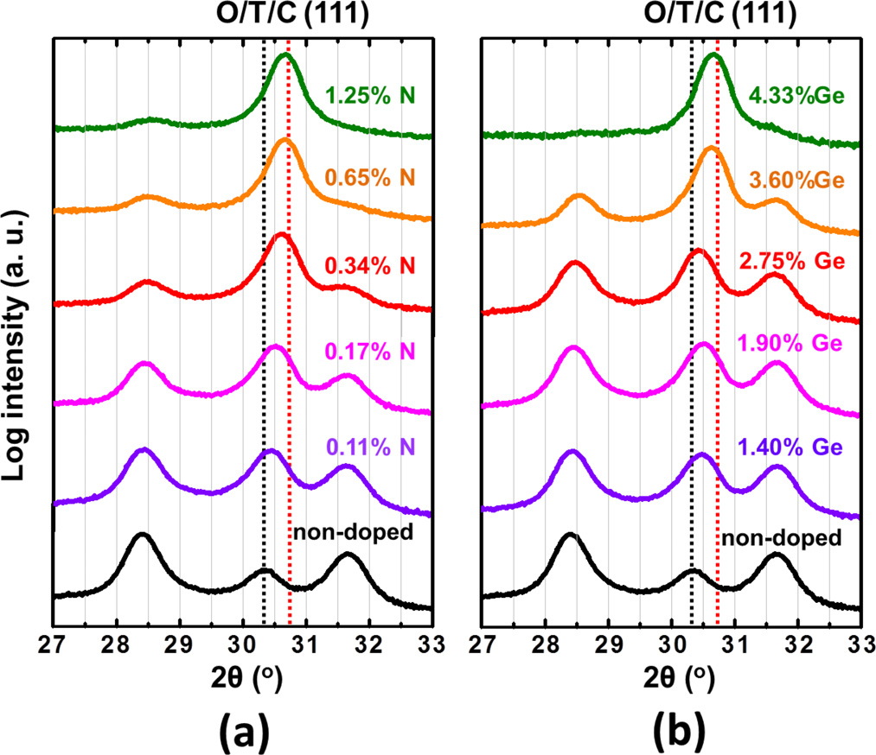

FIG. 3. GIXRD patterns of 27 (62) nm HfO2 films with (a) 0%, 0.11%, 0.17%, 0.34%, 0.65%, and 1.25% N doping concentrations, and (b) 0%, 1.40%, 1.90%, 2.75%, 3.60%, and 4.33% Ge doping concentrations. The black and red dot lines represent O/T/C (111) peak positions for non-doped and heavily doped HfO2, respectively. Note, the O/T/C phase is described in the face-centered setting. A part of data in the panel (a) is replotted from Ref. 12.

|  |  |  |
| --- | --- | --- |
| 124104-4 | Xu et al. | J. Appl. Phys. 122, 124104 (2017) |

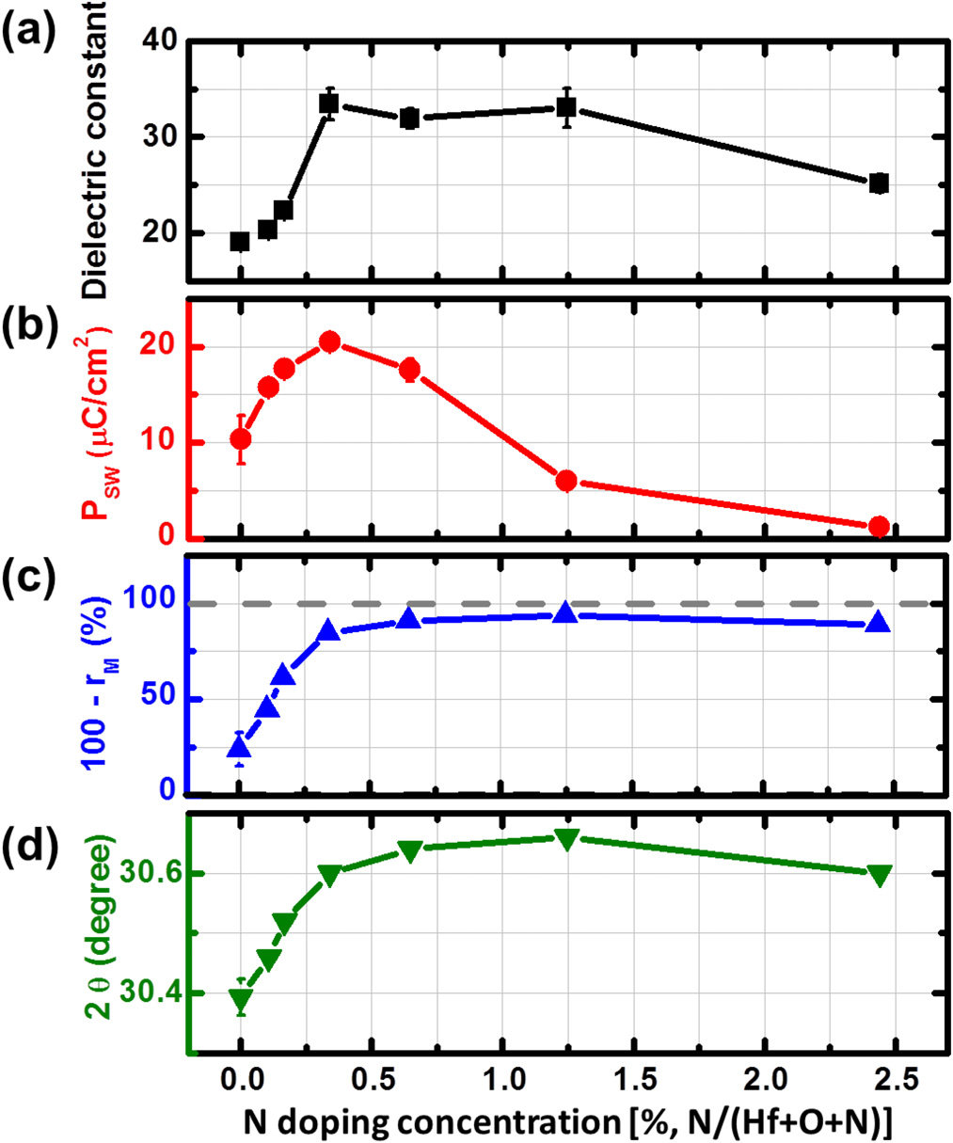

FIG. 4. (a) Relative dielectric constant, (b) switchable polarization PSW, (c) O/T/C phase fractions (%, O/T/C fract. ¼ 100 � rM) and (d) O/T/C (111) peak positions of 27 (62) nm N-doped HfO2 films. The dielectric constant was estimated from the central crossing point of C�E curves. PSW is equal to the difference between Prþand Pr�at the zero bias condition. The data in panels (a), (b), (c) are replotted from Ref. 12.

Zr4þincorporation does not affect the Vo density in HfO2 significantly, while two Sc3þ(Y3þ) atoms or two Nb5þ atoms will generate or eliminate one Vo by replacing two Hf4þatoms, respectively. Therefore, it is reasonable that the rM�dop% curves are different owing to the different Vo con-centrations in Sc-, Zr- and Nb-doped HfO2 films. In other

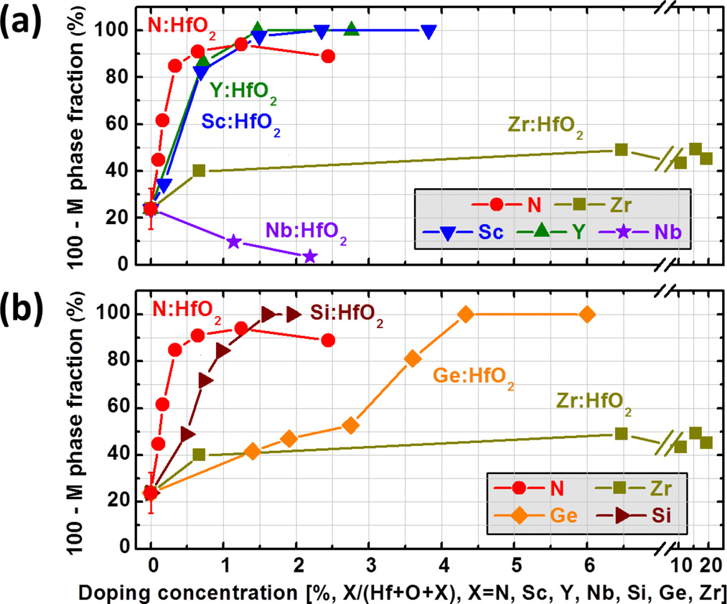

FIG. 5. The O/T/C phase fraction of 27 (62) nm HfO2 films are shown as a function of doping concentrations for various dopants: (a) Sc, Y, Zr, Nb, and N; (b) Si, Ge, Zr, and N. The doping concentration is defined by the total atomic percentage, dop% ¼ X/(Hf þ O þ X), in which X is the dopant atom.

words, this difference probably results from the various valence states of dopants.

On the other hand, in Fig. 5(b), the tetravalent dopants [Zr4þ(72 pm), Ge4þ(53 pm), and Si4þ(40 pm) with the coordination number of 6]32present a clear size-dependent effect on the HfO2 phase transition. Si incorporation shows a much stronger effect than Ge or Zr incorporation, which sug-gests that a smaller dopant can stabilize the O/T/C phase in HfO2 more efficiently. For Si or Ge doping, it is inferred that the shorter cation-oxygen bonding (e.g., Si-O and Ge-O) favors the tetragonal structure, in which each Hf atom has four shorter and four longer Hf-O bonds.33,34But in the cubic structure, eight Hf-O bonds have the same length, and thus the cubic phase is hard to be stabilized by Si or Ge dop-ing.33,34In addition, since the energy difference between the T phase and the ferroelectric O phase was estimated to be very small,10,35it is possible that the structural transition between these two phases may be driven by an external elec-tric field.10,35The antiferroelectric like behaviors are clearly observed in Ge- and Si-doped HfO2, as shown in Figs. 2(d), 2(g) and 2(h), which might be owing to the electric field induced reversible phase transition between the T phase and the ferroelectric O phase. On the contrary, the antiferroelec-tric behavior is not clearly observed in N-, Sc-, and Y-doped HfO2 films. It is possibly due to the fact that the stabilized phase (in the over-doping region) is the cubic phase rather than the tetragonal phase in N-, Sc-, and Y-doped HfO2 films. It is worthwhile to mention that Ge diffusion from the substrate into HfO2 was very weak (<0.03% Ge, confirmed by the SIMS profile of annealed non-doped HfO2).12   
 Next, the dopant-induced HfO2 ferroelectric transition is 0.34% N incorporation can drive the maximum ferroelectric-further discussed. As shown in Fig. 6, the Psw � dop% plot, ity in HfO2, and 0.7% doping concentration is needed for Si, Y, or Sc incorporation. For Ge or Zr doping, a much higher doping concentration is required. This tendency is the same as that in the dopant-induced HfO2 phase transition shown in Figs. 5(a) and 5(b). It is noted that another interesting point is that the maximum PSW is 22 (62) lC/cm2for all dopants used in this study.

Here, we notice the different dopant sensitivities in Fig. 6. Although both dopant size and Vo formation effects seem

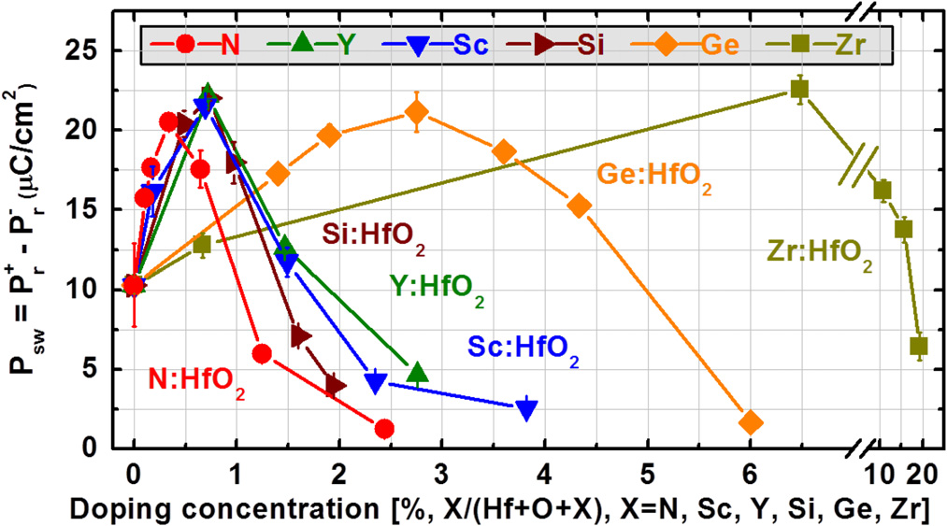

FIG. 6. Switchable polarization PSW of 27 (62) nm HfO2 films are shown as a function of doping concentrations for different dopants: Sc, Y, Si, Ge, Zr, and N. The doping concentration is defined by the total atomic percentage, dop% ¼ X/(Hf þ O þ X), in which X is the dopant atom.

|  |  |  |
| --- | --- | --- |
| 124104-5 | Xu et al. | J. Appl. Phys. 122, 124104 (2017) |

to contribute differently to the ferroelectric phase formation in HfO2, the Psw � dop% relationship looks like the same for all dopants in shape. This fact suggests that a same origin responsible for the ferroelectric phase formation may work in both Vo and dopant size effects. Therefore, we fit the data by a parabolic function to show the similarity, as follows:

|  |  |  |
| --- | --- | --- |
| PSW ¼ �a0 a � dop% � b0 | Þ2þ PMax SW; | (1) |

where a0 and b0 are dopant-independent constants, a is a dopant-dependent coefficient (the dopant sensitivity coeffi-cient), dop% is the atomic dopant percentage, and PMax SWis the maximum of the switchable polarization. As shown in Fig. 7(a), the PSW�dop% relationship could be well fitted by the parabolic function (solid curve) for each dopant with proper parameters, which are described next.

To fit the data graphically [Fig. 7(a)], the parabolic func-

smaller or larger than zero, respectively. Thus, “6” is

because Sc3þhas a similar ionic radius with Hf4þand the In the case of Sc doping, a is normalized to be 0.5, p ffiffiffiffiffiffiffiffiffiffiffiffiffiffiffiffiffiffiffiffiffiffiffiffi   
needed for .

dopant size effect will be reasonably ignorable. Then, based on the Eq. (2), the dopant sensitivity coefficient (a), a0 (76.1 lC/cm2), and b0 (0.384) can be estimated. a of Y is 0.5, indi-cating that the Vo formation contributes dominantly to the ferroelectric phase transition in Y-doped HfO2. For Si, Ge, and Zr, a is 0.5, 0.15, and 0.06, respectively. a value is dra-matically increased with the decrease of the tetravalent dopant size. It is interesting to see that a is about 1.0 for N, which is plausible in terms of two contributions, the Vo formation and the bonding distortion around N atoms.

Possible universal driving force for ferroelectric HfO2

tion is transformed to a linear one as follows: formation

6 q ffiffiffiffiffiffiffiffiffiffiffiffiffiffiffiffiffiffiffiffiffiffiffi ¼ p

ffiffiffiffiffi ð a � dop% � b0 Þ: (2)

function of dop% in Fig. 7(b), in which a good linearity is p ffiffiffiffiffiffiffiffiffiffiffiffiffiffiffiffiffiffiffiffiffiffiffiffi

The experimental data of 6 is shown as a

seen for N, Sc, Y, Si, Ge, and Zr. PSW can reach the maxi-

mum value (PMax

With a lower or higher dop%,

SW¼ 22 lC=cm2) with an optimized dop%. p

ffiffiffiffiffi ða � dop% � b0Þ is

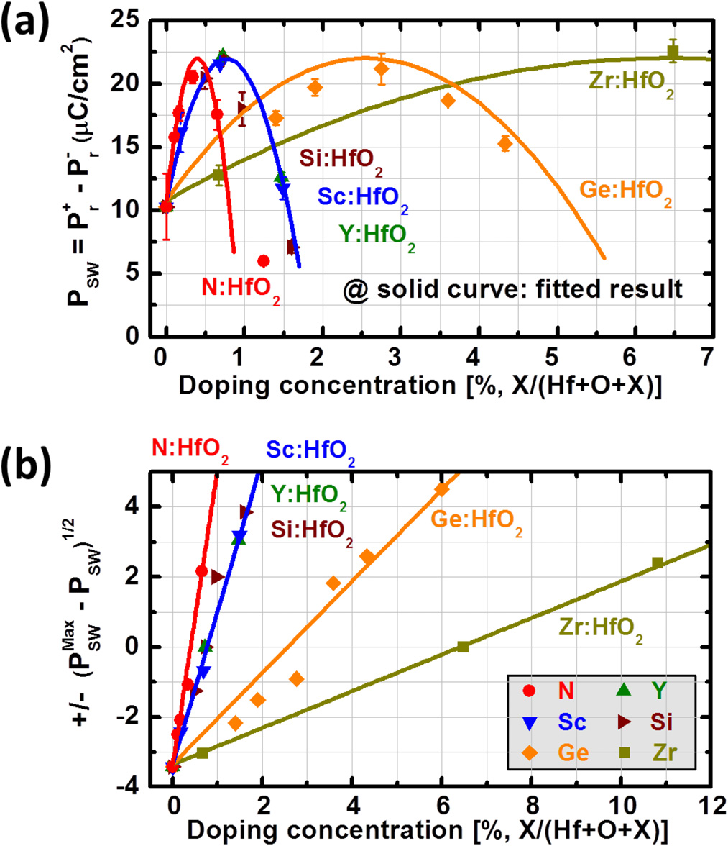

FIG. 7. (a) Dopant-induced HfO2 ferroelectric transition can be well fitted

by a parabolic function, PSW ¼ �a0ða � dop% � b0Þ2þ PMax and b0 are two dopant-independent constants, a is a dopant-dependent coeffi-

SW, in which a0

cient (the dopant sensitivity coefficient), dop% is the doping concentration,

and PMax is the maximum of switchable polarization (22 lC/cm2). (b)

all dopants, which presents a good linearity. p ffiffiffiffiffiffiffiffiffiffiffiffiffiffiffiffiffiffiffiffiffiffiffi

The 6 is shown as a function of the doping concentration for

The experimental results obtained so far indicate that M, O and T/C phases coexist in the present polycrystalline HfO2 films. Therefore, the switchable polarization, PSW, is in prin-ciple related to both the ferroelectric O phase ratio and the polarization orientation. The doping was unlikely to affect HfO2 orientation properties very much, which was supported by a wide-area reciprocal space mapping (WRSM) with a h� 2h scan and different sample’s inclination angles (not shown). Thus, the same maximum PSW approximately exhib-its the same maximum ferroelectric O phase ratio in doped HfO2 films. The relationship between PSW and HfO2 phase composition (the monoclinic phase fraction) is shown in Fig. 8. It is noted that all experimental data are on a unique transi-tion pathway (blue arrow) irrespective of dopant species. Interestingly, the data of non-doped HfO2 with different annealing temperatures (500 � 700�C) are on this trajectory as well. It is strongly suggested that there may be a same driving force for the ferroelectric O phase stabilization in

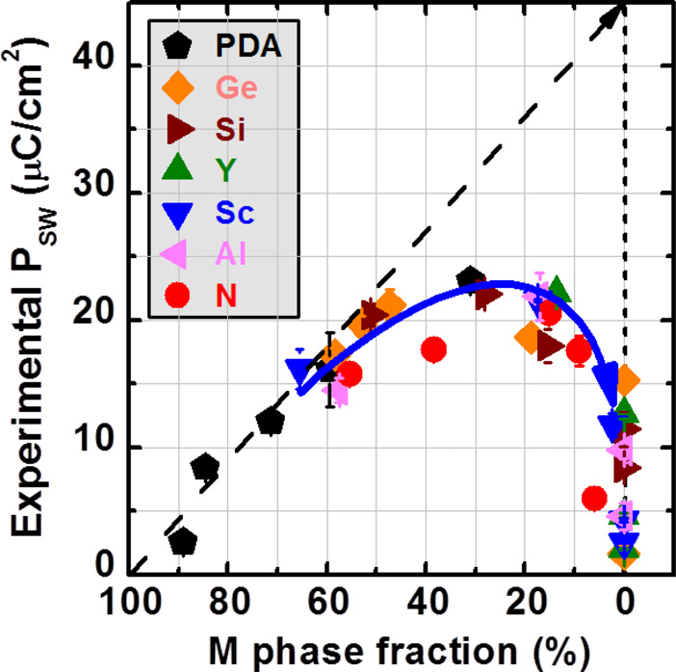

FIG. 8. Measured switchable polarization (PSW) is shown as a function of the monoclinic phase fraction for various dopants. All experiment data are on the same phase transition pathway (blue arrow). Note that the data of non-doped HfO2 films with different annealing temperatures are provided as well (PDA). Al-doped HfO2 is shown in Figs. 8 and 9, but not in Figs. 5–7. In the case of Al doping, the measured Al doping concentration (very small, dop% < 1.0% for maximum PSW) has a large error bar owing to the small Al peak sensitivity in XPS.

|  |  |  |
| --- | --- | --- |
| 124104-6 | Xu et al. | J. Appl. Phys. 122, 124104 (2017) |

these HfO2 films. In the case of slight doping, PSW is larger than 15 lC/cm2even though the O/T/C phase fraction is only 50%, and thus the ferroelectric O phase is expected to be the dominant one in O/T/C phases. By further increasing the dopant concentration, the T/C phase will become the dominant one, and as a result, the ferroelectricity is strongly suppressed in heavily doped HfO2 (the O/T/C phase ratio reaches 100%). Here, Zr doping is not included, because Zr-doped HfO2 cannot be regarded as a diluted HfO2 system.

Moreover, structural properties of doped HfO2 are dis-cussed in Fig. 9, in which the O/T/C (111) peak position is shown as a function of the M phase fraction. By increasing the doping concentration, the 2h peak position shifts from 30.40�to 30.65�. From this result, it is concluded that�30.40�and �30.65�are probably responsible for the ferro-electric O phase and the T/C phase, respectively. It is consis-tent with the lattice constants calculated for the ferroelectric O phase (5.02 � 5.04 � 5.22 A˚ , 2h ¼ 30.39�),10T phase (5.03� 5.03 � 5.12 A˚ , 2h ¼ 30.58�),10and C phase (5.03 � 5.03� 5.03 A˚ , 2h ¼ 30.76�),10respectively. Figure 9 also suggests that the dopant-induced structural transformation in HfO2 is independent of dopant species as long as that the doped HfO2 could be regarded as a diluted system. Nevertheless, it is not easy to judge the crystalline structure only by XRD, and fur-ther microscopic study will be needed, for example, with the electron beam diffraction analysis.

Finally, the phase transition route is discussed. The unique transition route in Fig. 8 is understandable by consid-ering that the kinetic pathway of the dopant-induced HfO2 phase transition along the T/C, ferroelectric O, and M phases may be the same. It is noted that the ferroelectric O phase can be stabilized at the transition boundary between the M phase and the T/C phase. This means that the ferroelectric O phase seems to be an intermediate phase. At the T–M phase transition, the T–O phase transition might be the first step, followed by the O–M phase transition. Namely, the stabiliza-tion of the ferroelectric O phase is much more related to the phase transition kinetics rather than its thermodynamics. The

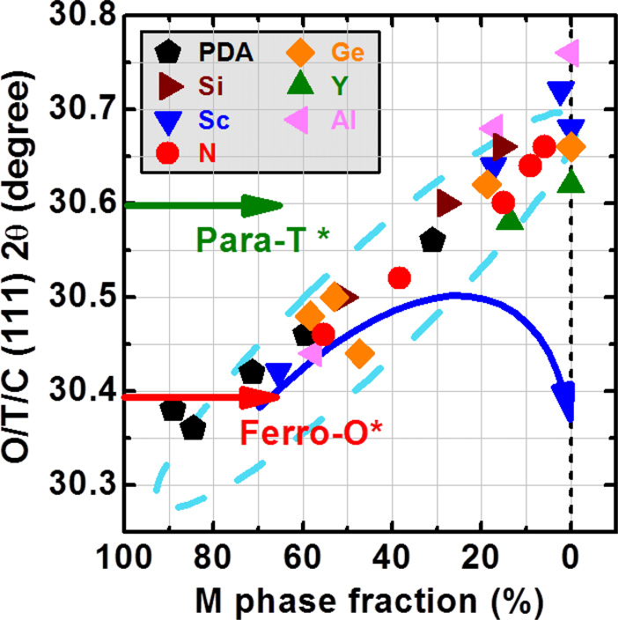

FIG. 9. The O/T/C (111) peak positions are shown as a function of the monoclinic phase fraction for various dopants. The red and green arrows represent the theoretical values for the ferroelectric O phase and the T phase in Ref. 10, respectively. The blue arrow is the universal phase transition

phase transition (e.g., T–M) can be driven by the free energy difference (DGc) between the parent phase and the product phase. But considering the kinetic process, an intermediate phase (metastable) might be formed first for lowering the activation energy between the parent phase and the product phase. The activation energy is related to both the strain energy (DUstrain) and the interface energy (DUinterface, an excess energy at the interface between the parent phase and the product phase).35Unlike the T–M phase transition which is accompanied by a large volume expansion (DV � 5.9%) and shape strain (dominated by a shear stain, c � 0.15), the volume increase (DV � 2.0%) and shape strain (dominated by a dilatational strain, n � 0.02) are much smaller in the T–O phase transition.35,36Therefore, from the viewpoint of the kinetic transition process, the strain condition (related to DUstrain) and grain size (related to DUinterface) are critically important for stabilizing the ferroelectric O phase in HfO2.

CONCLUSIONS

Dopant-induced structural and ferroelectric transitions in HfO2 have been systematically studied by doping various cations (Sc, Y, Al, Nb, Si, Ge, Nb) and an anion (N) into HfO2. First, it has been found that the doping sensitivity is quantitatively quite different among various dopants for the HfO2 ferroelectric transition, while the maximum switching polarization value is almost the same. Both the Vo and dop-ant size effects are responsible for these different dopant sensitivity coefficients. Moreover, it is inferred that the dopant-induced HfO2 phase transition pathway is almost the same for all dopants. We consider it is more related to the kinetic process of the T–O–M phase transition, in which the ferroelectric O phase formation might significantly reduce the activation energy between the T phase and the M phase. From these findings, it is conjectured that the ferro-electric O phase might be in the intermediate state between the T phase and the M phase. With the dopant concentration increase, HfO2 crystalline symmetry changes from the lower to higher, and thus the intermediate orthorhombic phase may appear. Higher doping concentration will finally stabilize the more symmetric T/C phase. It is in good agreement with experimental results. However, it is still difficult to under-stand why the ferroelectric orthorhombic (non-centrosymmet-ric in place of centrosymmetric orthorhombic) phase appears at an appropriate dopant concentration. Further microscopic study of the difference between ferroelectric and paraelectric orthorhombic phases is needed.

ACKNOWLEDGMENTS

This work was supported by JST-CREST Grant No. JPMJCR14F2, Japan.

1J. H. Choi, Y. Mao, and J. P. Chang, [Mater. Sci. Eng., R](http://dx.doi.org/10.1016/j.mser.2010.12.001) 72, 97 (2011). 2M. H. Park, Y. H. Lee, H. J. Kim, Y. J. Kim, T. Moon, K. D. Kim, J. Muller, A. Kersch, U. Schroeder, T. Mikolajick, and C. S. Hwang, [Adv. Mater.](http://dx.doi.org/10.1002/adma.201404531) 27, 1811 (2015).

3J. Muller, E. Yurchuk, T. Schlosser, J. Paul, R. Hoffmann, S. Muller, D. Martin, S. Slesazeck, P. Polakowski, J. Sundqvist, M. Czernohorsky, K.

pathway in Fig. 8. Seidel, P. Kucher, R. Boschke, M. Trentzsch, K. Gebauer, U. Schroder,

|  |  |  |
| --- | --- | --- |
| 124104-7 | Xu et al. | J. Appl. Phys. 122, 124104 (2017) |

and T. Mikolajick, in Symposium on VLSI Technology (VLSIT) (2012), pp.

25–26.

4S. Mueller, J. Muller, R. Hoffmann, E. Yurchuk, T. Schlosser, R. Boschke,

J. Paul, M. Goldbach, T. Herrmann, A. Zaka, U. Schroder, and T.

Mikolajick, [IEEE Trans. Electron Devices](http://dx.doi.org/10.1109/TED.2013.2283465) 60(12), 4199 (2013).

5S. Salahuddin and S. Datta, [Nano Lett.](http://dx.doi.org/10.1021/nl071804g) 8, 405 (2008).

6M. Kobayashi and T. Hiramoto, [AIP Adv.](http://dx.doi.org/10.1063/1.4942427) 6(2), 025113 (2016).

7T. S. Boscke, J. Muller, D. Brauhaus, U. Schroder, and U. Bottger, [Appl.](http://dx.doi.org/10.1063/1.3634052)

[Phys. Lett.](http://dx.doi.org/10.1063/1.3634052) 99, 102903 (2011).

8T. S. Boscke, S. Teichert, D. Brauhaus, J. Muller, U. Schroder, U. Bottger,

and T. Mikolajick, [Appl. Phys. Lett.](http://dx.doi.org/10.1063/1.3636434) 99, 112904 (2011).

9T. D. Huan, V. Sharma, G. A. Rossetti, Jr., and R. Ramprasad, [Phys. Rev.](http://dx.doi.org/10.1103/PhysRevB.90.064111)

[B](http://dx.doi.org/10.1103/PhysRevB.90.064111) 90, 064111 (2014).

10R. Materlik, C. Kunneth, and A. Kersch, [J. Appl. Phys.](http://dx.doi.org/10.1063/1.4916707) 117, 134109

(2015).

11X. Sang, E. D. Grimley, T. Schenk, U. Schroeder, and J. M. LeBeau, [Appl.](http://dx.doi.org/10.1063/1.4919135)

[Phys. Lett.](http://dx.doi.org/10.1063/1.4919135) 106, 162905 (2015).

12L. Xu, T. Nishimura, S. Shibayama, T. Yajima, S. Migita, and A. Toriumi,

[Appl. Phys. Express](http://dx.doi.org/10.7567/APEX.9.091501) 9, 091501 (2016).

13P. Polakowski and J. Muller, [Appl. Phys. Lett.](http://dx.doi.org/10.1063/1.4922272) 106, 232905 (2015). 14T. Nishimura, L. Xu, S. Shibayama, T. Yajima, S. Migita, and A. Toriumi,

[Jpn. J. Appl. Phys., Part 1](http://dx.doi.org/10.7567/JJAP.55.08PB01) 55, 08PB01 (2016).

15E. Yurchuk, J. Muller, S. Knebel, J. Sundqvist, A. P. Graham, T. Melde,

U. Schroder, and T. Mikolajick, [Thin Solid Films](http://dx.doi.org/10.1016/j.tsf.2012.11.125) 533, 88 (2013).

16J. Y. Dai, P. F. Lee, K. H. Wong, H. L. W. Chan, and C. L. Choy, [J. Appl.](http://dx.doi.org/10.1063/1.1585116)

[Phys.](http://dx.doi.org/10.1063/1.1585116) 94, 912 (2003).

17K. Kita, K. Kyuno, and A. Toriumi, [Appl. Phys. Lett.](http://dx.doi.org/10.1063/1.1880436) 86, 102906 (2005). 18P. M. Kelly and L. R. F. Rose, [Prog. Mater. Sci.](http://dx.doi.org/10.1016/S0079-6425(00)00005-0) 47, 463 (2002).

19P. Li, I. W. Chen, and J. E. Penner-Hahn, [J. Am. Ceram. Soc.](http://dx.doi.org/10.1111/j.1151-2916.1994.tb06964.x) 77(1), 118

(1994).

20P. Li, I. W. Chen, and J. E. Penner-Hahn, [J. Am. Ceram. Soc.](http://dx.doi.org/10.1111/j.1151-2916.1994.tb05403.x) 77(5), 1281 (1994).

21P. Li, I. W. Chen, and J. E. Penner-Hahn, [J. Am. Ceram. Soc.](http://dx.doi.org/10.1111/j.1151-2916.1994.tb05404.x) 77(5), 1289 (1994).

22J. Muller, U. Schroder, T. S. Boscke, I. Muller, U. Bottger, L. Wilde, J. Sundqvist, M. Lemberger, P. Kucher, T. Mikolajick, and L. Frey, [J. Appl. Phys.](http://dx.doi.org/10.1063/1.3667205) 110, 114113 (2011).

23S. Mueller, J. Mueller, A. Singh, S. Riedel, J. Sundqvist, U. Schroeder, and T. Mikolajick, [Adv. Funct. Mater.](http://dx.doi.org/10.1002/adfm.201103119) 22, 2412 (2012).

24J. Muller, T. S. Boscke, U. Schroder, S. Mueller, D. Brauhaus, U. Bottger, L. Frey, and T. Mikolajick, [Nano Lett.](http://dx.doi.org/10.1021/nl302049k) 12, 4318 (2012).

25S. Mueller, C. Adelmann, A. Singh, S. Van Elschocht, U. Schroeder, and T. Mikolajick, [ECS J. Solid State Sci. Technol.](http://dx.doi.org/10.1149/2.002301jss) 1(6), N123 (2012).

26S. Starschich and U. Boettger, [J. Mater. Chem. C](http://dx.doi.org/10.1039/C6TC04807B) 5, 333 (2017).

27U. Schroeder, E. Yurchuk, J. Muller, D. Martin, T. Schenk, P. Polakowski, C. Adelmann, M. I. Popovici, S. V. Kalinin, and T. Mikolajick, [Jpn. J. Appl. Phys., Part 1](http://dx.doi.org/10.7567/JJAP.53.08LE02) 53, 08LE02 (2014).

28A. Navrotsky, [J. Mater. Chem.](http://dx.doi.org/10.1039/b417143h) 15, 1883 (2005).

29S. Ostanin, E. Salamatov, A. J. Craven, D. W. McComb, and D. Vlachos, [Phys. Rev. B](http://dx.doi.org/10.1103/PhysRevB.66.132105) 66, 132105 (2002).

30T. Iwai, Y. Nakajima, T. Nishimura, K. Nagashio, and A. Toriumi, in International Conference on Solid State Devices and Materials, p. 767 (2012). 31H. K. Schmid, [J. Am. Ceram. Soc.](http://dx.doi.org/10.1111/j.1151-2916.1987.tb05009.x) 70(5), 367 (1987).

32R. D. Shannon, [Acta Crystallogr., Sect. A](http://dx.doi.org/10.1107/S0567739476001551) 32, 751 (1976).

33C. K. Lee, E. Cho, H. S. Lee, C. S. Hwang, and S. Han, [Phys. Rev. B](http://dx.doi.org/10.1103/PhysRevB.78.012102) 78, 012102 (2008).

34D. Fischer and A. Kersch, [J. Appl. Phys.](http://dx.doi.org/10.1063/1.2999352) 104, 084104 (2008).

35S. E. Reyes-Lillo, K. F. Garrity, and K. M. Rabe, [Phys. Rev. B](http://dx.doi.org/10.1103/PhysRevB.90.140103) 90, 140103 (2014).

36E. H. Kisi, [J. Am. Ceram. Soc.](http://dx.doi.org/10.1111/j.1151-2916.1998.tb02402.x) 81(3), 741 (1998).